**What factors influence the abundance of photosynthetic proteins in leaves? Quantitative, continental-scale ecological proteomics in wild Eucalypts**

Marketing:

Photosynthesis is arguably the most important chemical reaction for life on Earth. Inputs are CO2, H20 and light; outputs are carbohydrates and O2, as well as various small organic molecules which feed into metabolic networks.

The way plants construct the complexes and enzymatic networks which catalyse the reactions of photosynthesis determines and is determined by their propensity / ability to photosynthesise under varying environmental conditions.

The last decade has produced revolutionary new methods for investigating how organisms function at the molecular level. In particular, advances in proteomics now allow for high-throughput processing of biological samples in non-model organisms.

This is the requisite technology to ask how photosynthesis is optimised at the molecular level in wild plants, across gradients of environmental conditions.

We use a novel quantitative proteomics method to characterise abundance of leaf proteins of 33 species of *Eucalyptus, Corymbia and Angophora*

Research questions:

1. Does photosynthetic protein abundance in leaves follow biogeographic gradients (temp, rainfall, soil chemistry)?

* Are proteins involved in light harvesting or CO2 assimilation more responsive to environmental conditions?
* Hypotheses (re: Hikosaka & Terashima 1995):
  + Calvin cycle proteins will be most abundant at low rainfall, so as to effect greater Ci drawdown at lower time-averaged Gs.
  + Calvin cycle enzymes and electron transport proteins will be more abundant in high light conditions, as they determine rate of light-saturated photosynthesis.
  + Photosystem complex proteins will be most abundant at higher rainfall sites where shading is greater, and photosynthesis is limited by light
* Would be ideal to answer these q’s using avg molar ratios of photosystem proteins / Calvin cycle proteins plotted over gradients, but we need the QCONCAT standards

1. Is there an influence of genetic lineage on the response of photosynthetic protein abundance to environmental conditions?
2. How do abundances of photosynthetic proteins change with leaf age?

* Hypotheses:
  + Abundance of light harvesting proteins increases with age to counter reduced light interception
    - Is there any effect of leaf age independent of increased shading? Can’t answer this directly but worth discussing
  + Calvin cycle & electron transport proteins remain constant or are proportionally reduced as leaves age
  + Nitrogen is progressively allocated to recalcitrant structural and defensive protein throughout leaf lifespan, so older leaves contain proportionally less photosynthetic protein
    - Re: Onoda et al. 2003 “Allocation of nitrogen to cell walls decreases photosynthetic nitrogen-use efficiency”
    - But see Hikosaka & Shigeno 2009 “nitrogen allocation to cell walls does not explain the variation in PNUE”
    - Have not quantified structural / cell-wall associated proteins here

1. To what extent is variation in photosynthetic protein abundance driven by different environmental factors?

Study design:

* Fully replicated ecological study design, across a span of leaf ages
* Continental scale transects at three latitudes in eastern Australia (map), spanning gradients of temperature and rainfall

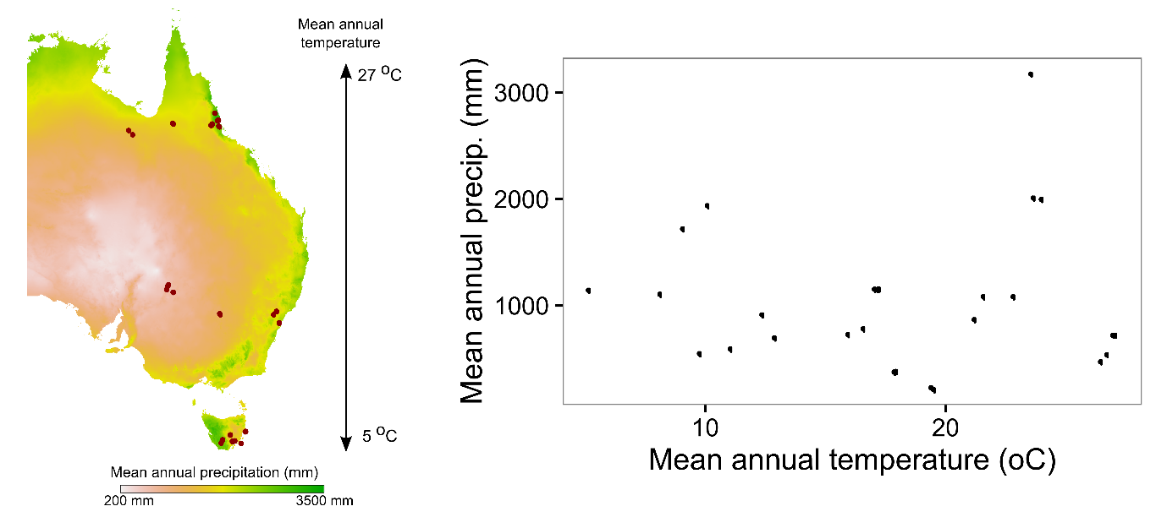

Figures:

1a - [Calvin cycle] vs precip

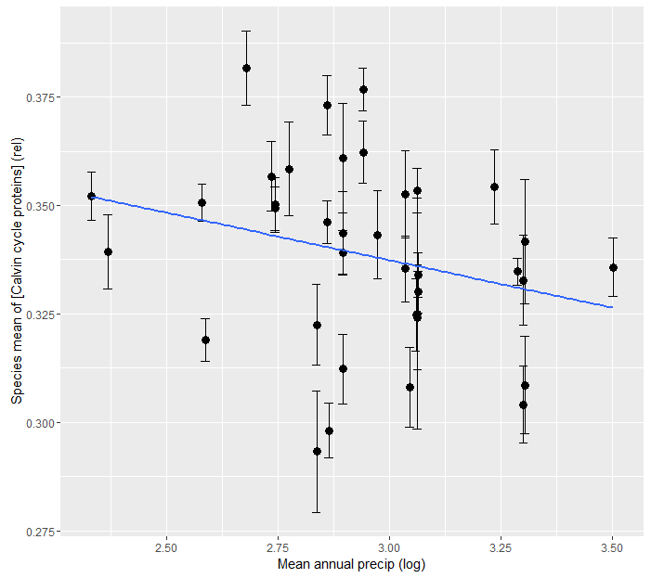

1b - [Calvin cycle] vs gap fraction

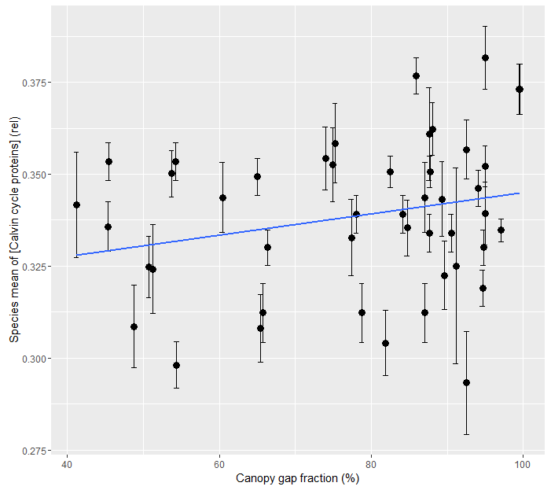

1c - [electron transport] vs precip

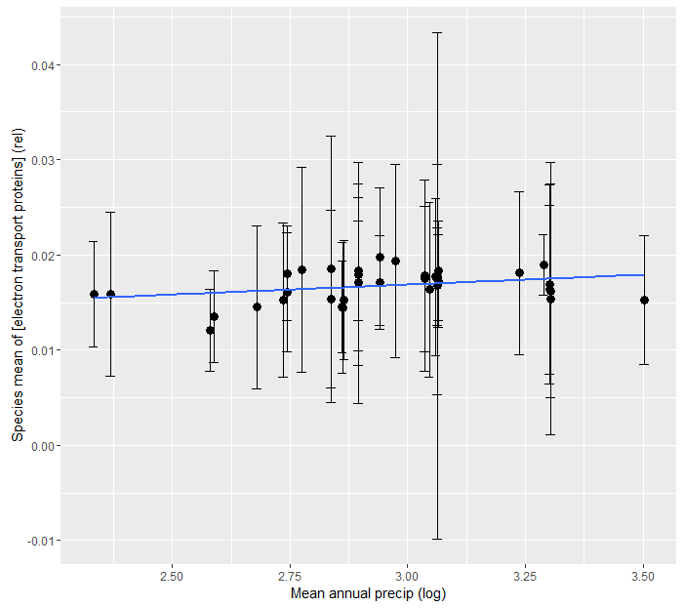

1d - [electron transport] vs gap fraction

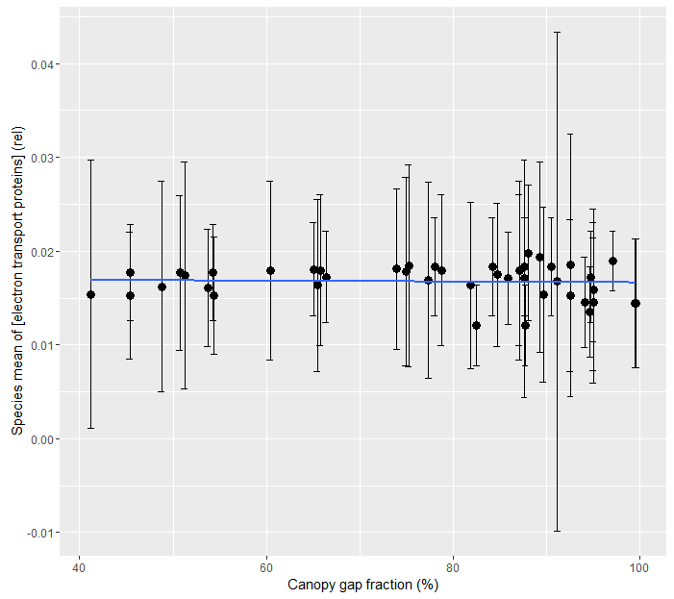

Check out that point with negative std error

* Data is skewed (high outlier) – strange distribution within 9 points to create std error that’s greater than the mean
* Why might that be?
* Is it proteomics error?

1e - [photosystems] vs precip

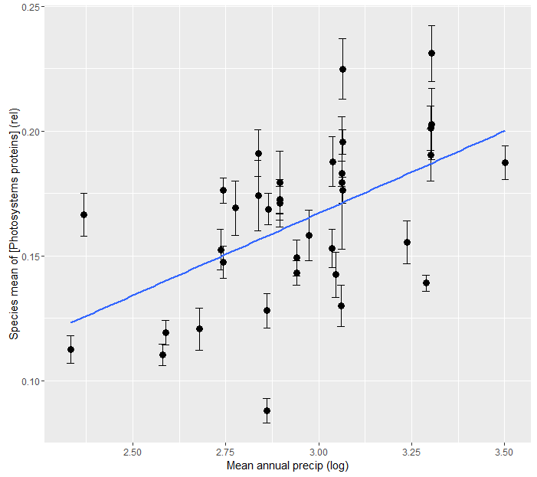

R2 = 0.28

1f - [photosystems] vs gap fraction

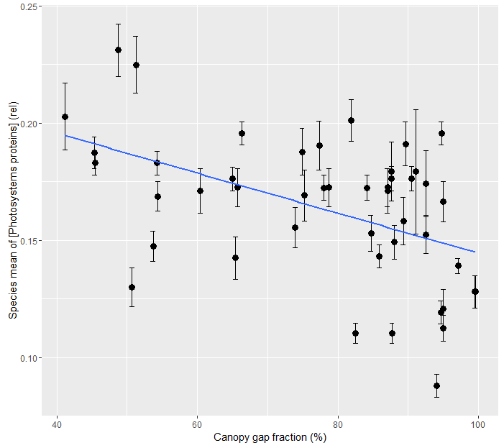

R2 = 0.22

2a – photosystems vs precip (lineage)

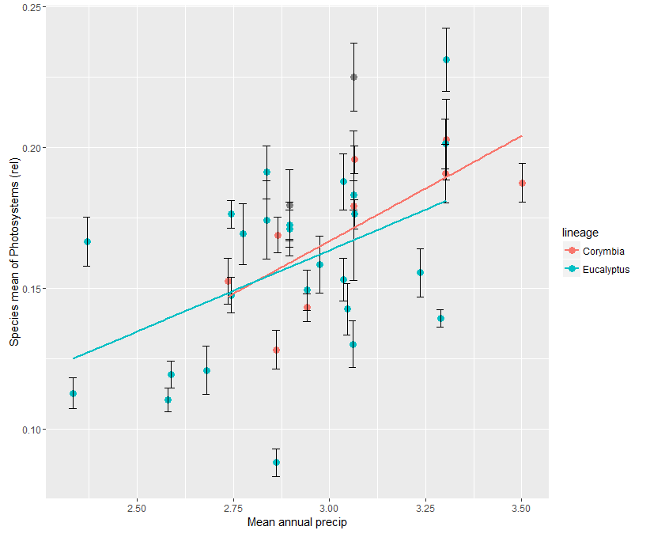

2b – photosystems vs gap fraction (lineage)

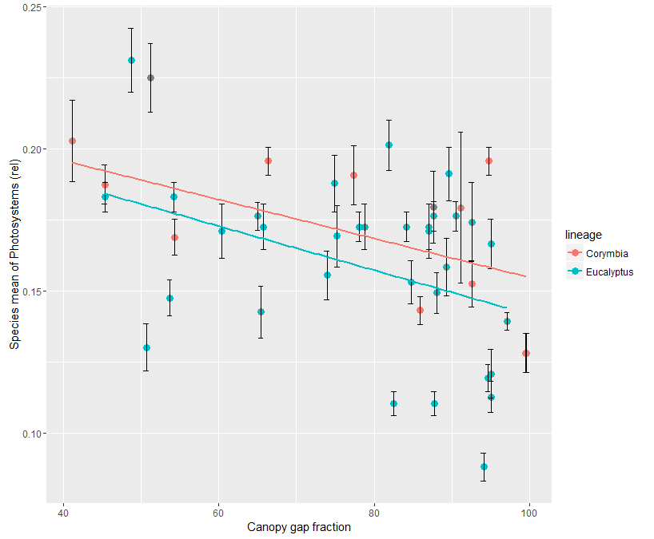

Leaf age:

Normalise to newest leaf on the branch, should tighten scatter and remove interspecific variation fx

3a - total protein vs leaf_age

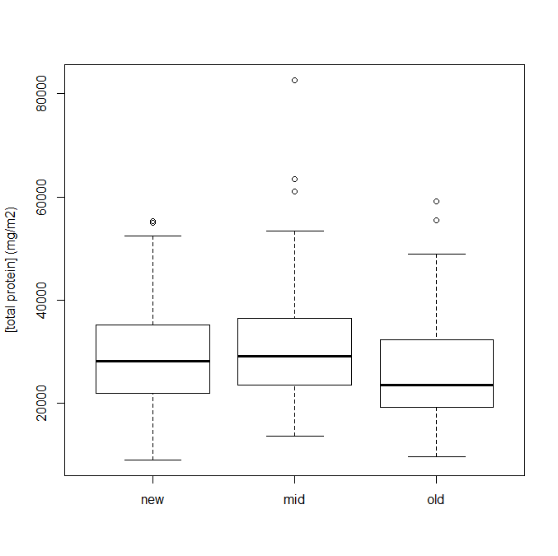

3b – photosystems vs leaf age

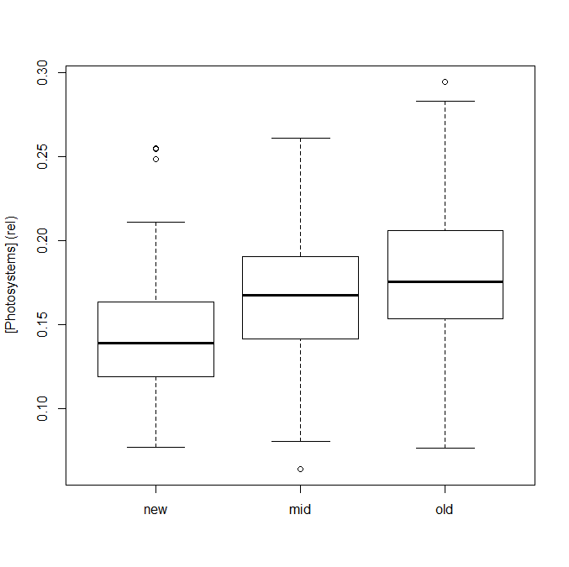

3c – electron transport vs leaf age

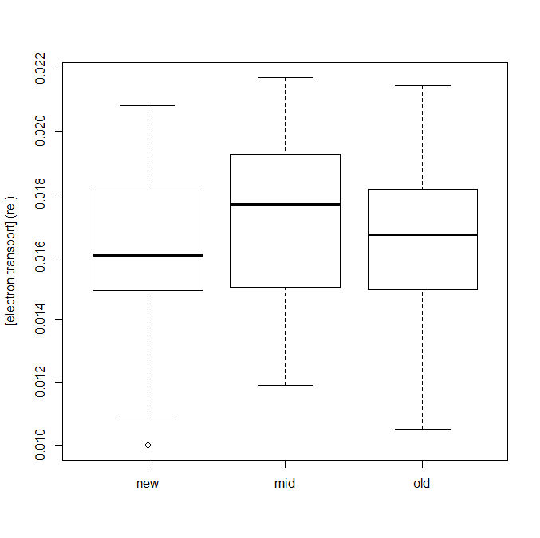

3d – Calvin cycle vs leaf age

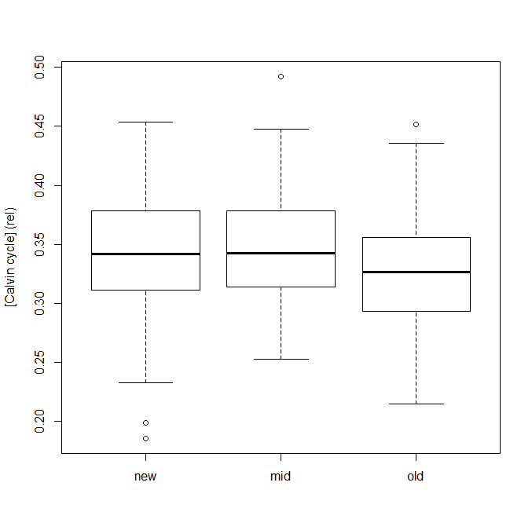

4 – variance partitioning (X1 = soil N (modelled), X2 = gap fraction, X3 = precip, X4 = tavg)

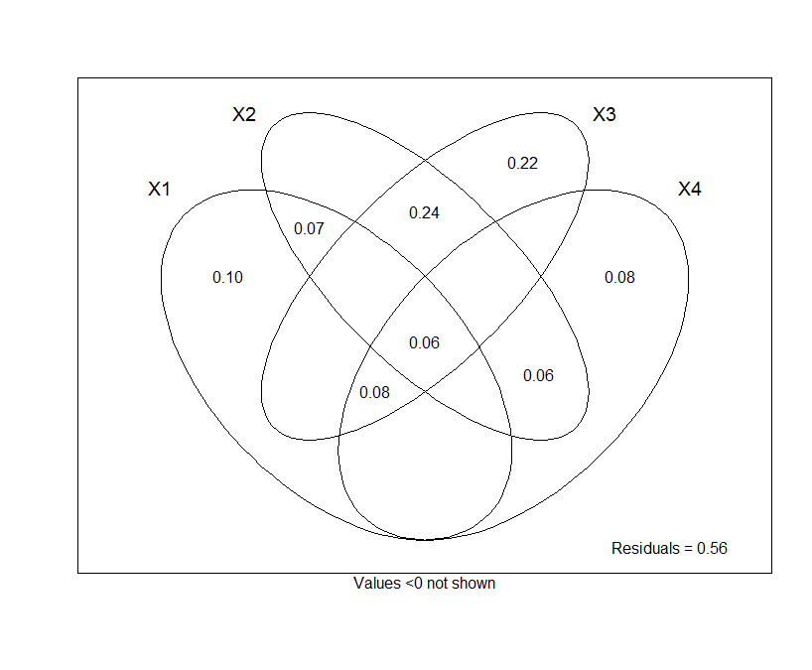

Tavg not significant by itself, but does play a role in multiple regression…

**Notes:**

Haven’t included average temperature even though it was a key part of the study design. Need to update hypotheses to include understanding of how tavg might play a role (esp for calvin cycle / aridity interplay)

Haven’t used aridity (currently have data for Cramer-Prentice aridity, stronger relationships w precip although aridity is more intuitive)

Look at respiration & tavg, also trend with total protein and temperature

General background info:

Total protein & total N across gradients, perhaps in supp. Info.

What sort of fraction of protein (as inferred from total N) are we extracting

Depending on journal could be brisk with graphs in supp info, or more extensive

Lineage to go into supp info

Measure standard deviations at different levels (species x site, leaf age, etc.)

Stdev between spp. is x* stdev within species

Average standard deviation within species (i.e. what error bars show – except corresponding stdev)

Stdev between species within site

__ ignore above __

Is stdev of species means bigger than stdev between individual leaves?

* Should plot with y axes reaching down to zero

TAVG hypothesis:

In colder conditions (at high light?), should have more calvin cycle enzymes to make up for slower reaction rate